**Report**

While doing this assignment I faced a lot of issues , firstly because of personal issues such as the fact that I am from a non-IT background .I had very little to no previous knowledge about the subjects that I am leaning in this course. Secondly, I could not find anyone to form a group with so I had to do this individually and figure things out by myself.

On the technical front, firstly an error related to tweepy was showing up many a times , I tried a lot of measures to resolve that like uninstalling and reinstalling it , trying updating it , starting the whole thing from scratch , setting a limit etc .

Secondly, my twitter developer account suspended for some reason which I am not aware of , then I had the credentials provided in the blackboard and it worked out.

Then finally somehow I was able to resolve that , later when finally everything was fine , the code was alright , no errors showed up but yet it was not running ,I tried rewriting the files and some new ones as well ,but still I was unable to figure out the issue because there did’nt seem to be any issue with the code to me . Then later some time I tried again executing the same thing which was not running earlier , this time it did , the tweets showed up and I concluded that maybe due to some technical issue or maybe just the fact that sometimes it takes time to load , was the only reason behind the delay. That’s how I did the twitter part .

1. Installation and setup of zookeeper:

2.apache-kafka

3.programming files

4.tweets showing up

Cleaning and processing data

Firstly error showed up because maybe “date” word is reserved by hive so I can’t use that for creating column name , so I modified it to “tweet_date” and it worked :

For convenience I dropped this table and changed the table name to BigData_tweets

I cleaned the tweets using the following 4 commands:

**RECORDINGS:**

(double click to view):

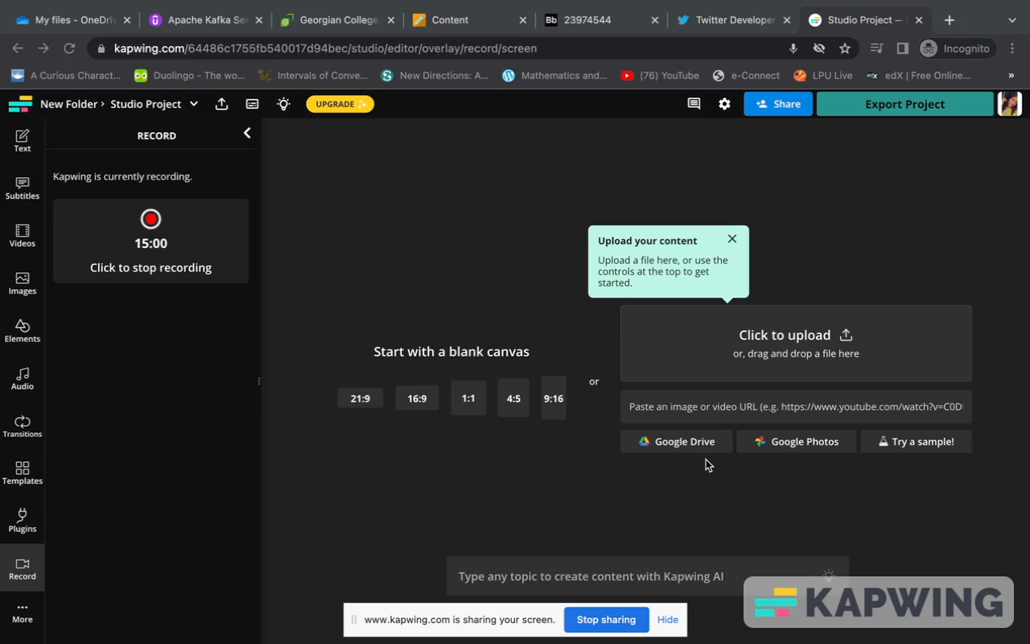



Programming Files screenshots:

Consumer.py:

Producer-twitter.py:

